COURSE CODE/TITLE: |  |  | SECTION:
DATE PERFORMED: | 10 -14-26 |  | DATE SUBMITTED: | 10-14-26
NAME: | Sean Andrei Evangelista |  | INSTRUCTOR: | Robin Valenzuela

ACTIVITY NO. ___ | [ACTIVITY NAME]
1. PROCEDURE OUTPUT
What procedures did you perform?

2. ANSWERS TO SUPPLEMENTAL ACTIVITY
1. Create a program in C++ that will convert a user-input Farenheight to Celcius and vice versa. Use functions
in the program.

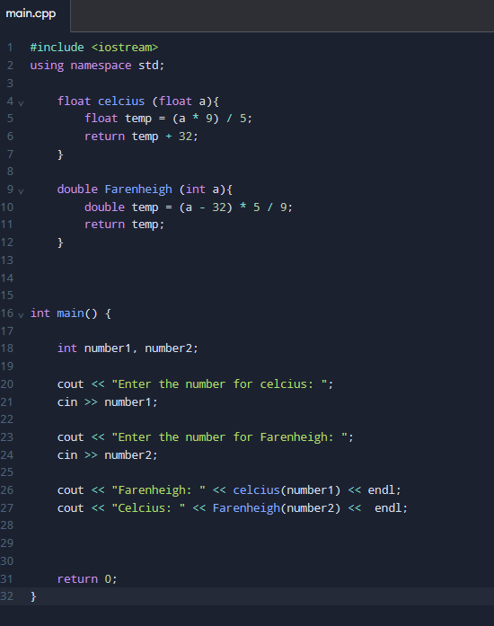
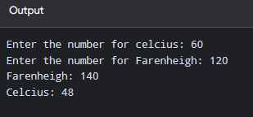
2. Create a program in C++ that will convert dollars into pesos and vice versa. Use functions in the program

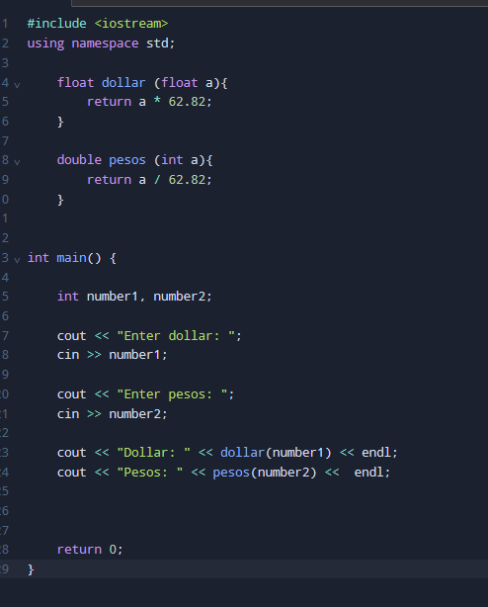
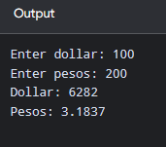

3. Create a C++ program for a Shopping Cart Price Calculator. The program must allow the user to enter the
prices and quantities of 5 different products. Store the prices and quantities in separate arrays and use for
loops to process the data. Create separate functions to calculate the total cost of each product, compute
the total bill, and determine the discount based on the following rules:
- 10% discount if the total bill is at least ₱3,000.
- 5% discount if the total bill is at least ₱1,500 but less than ₱3,000.
- No discount if the total bill is below ₱1,500.
Display each product's price, quantity, and subtotal, followed by the total bill, discount amount, and final
amount to pay.

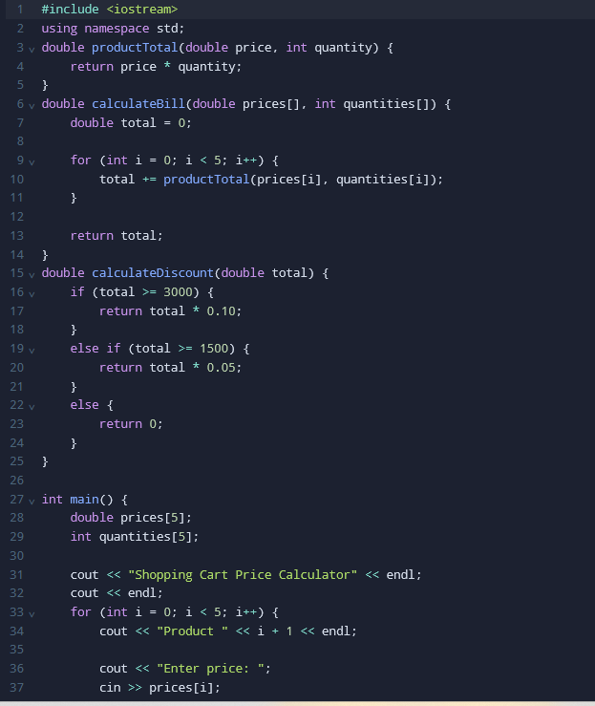
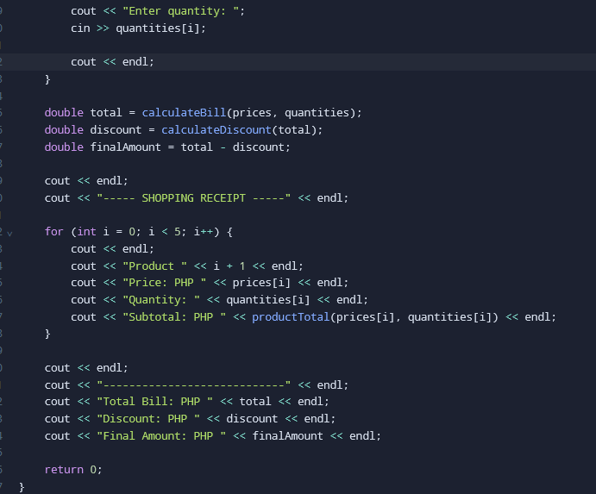
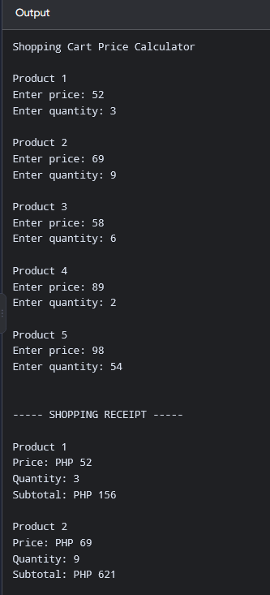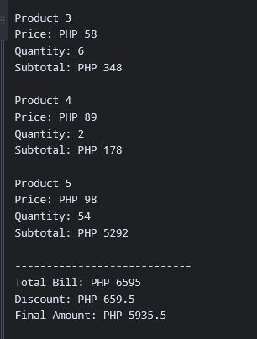
3. ARTIFICIAL INTELLIGENCE (AI) USE DISCLOSURE STATEMENT
I hereby declare that artificial intelligence (AI) tools were used, if applicable, in the preparation of this academic work. The following indicates the nature and extent of AI assistance:

Tools Used:
Examples: ChatGPT, Microsoft Copilot, Grammarly, QuillBot, etc.

Purpose of Use:
Examples: grammar correction, idea generation, formatting, summarization, code assistance, explanation of concepts, etc.

Extent of Use:
Explain how AI was used and confirm that it did not replace original thinking, analysis, authorship, or completion of the required work.

By submitting this activity, I affirm that my use of AI complies with T.I.P.’s AI usage policy and does not exceed the permitted limits for similarity, automated content generation, or academic assistance.

I understand that any false, incomplete, or misleading disclosure may be subject to investigation in accordance with due process and may result in sanctions for violation of existing T.I.P. policies.

Lab activities, templates, and related instructional materials shall not be reuploaded, reproduced, distributed, or shared with external organizations or third parties without the prior express written permission of the Technological Institute of the Philippines.

